## Front End Engineering-II

Project Report

Semester-IV (Batch-2022)

Title of the Project: -

SPORTX



**Supervised By: Submitted By:**

Raveesh Samkaria Taranpreet Kaur

Roll Number: 2210990908

Group - 13

**Department of Computer Science and Engineering**

## Chitkara University Institute of Engineering & Technology,

## Chitkara University, Punjab

**Abstract­**

Welcome to our online sports hub, where passion meets performance! Our website, crafted with precision using HTML and CSS, is your go-to destination for all things sports. Whether you're a dedicated athlete, a sports enthusiast, or simply someone who enjoys staying active, we have something for you.

But it's not just about information – we're also here to enhance your sports experience. Our interactive features and tools allow you to engage with fellow sports fans, track your progress, and even participate in virtual competitions. With seamless integration of HTML and CSS, we've created an immersive platform that brings the excitement of sports to life right at your fingertips.

Whether you're accessing our site from your desktop, tablet, or mobile device, our responsive design ensures a seamless experience across all platforms. So whether you're at home, on the go, or anywhere in between, you can stay connected to the world of sports whenever and wherever inspiration strikes.

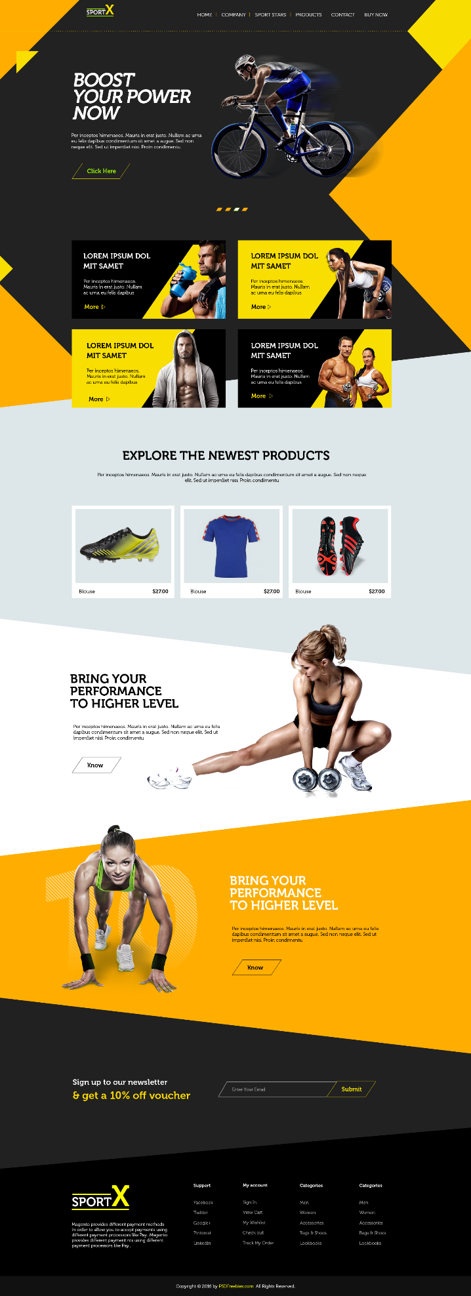

**Table of Contents**

|  |  |  |
| --- | --- | --- |
| Sr.no | Section | Page No |
| 1. | Introduction | 5 |
| 2. | Problem Statement | 6 |
| 3. | Technical Details | 7 |
| 4. | File Structure | 8 |
| 5. | Result | 9 |
| 6. | References | 37 |

**Introduction**

In today's digital age, a strong online presence is essential for businesses to effectively showcase their services and connect with their target audience. As such, the creation of a visually appealing and user-friendly website is permanent. This report documents the development and implementation of a front-end website for a Sportx, utilizing a combination of HTML and CSS.

HTM**L,** is the standard markup language for creating web pages and web applications. It provides the structure and content of a webpage by using a set of predefined tags or elements. These elements define the various parts of a webpage such as headings, paragraphs, links, images, and more. HTML documents are essentially text files with special tags that browsers interpret to render the content visually.

**CSS**, on the other hand, is a style sheet language used for describing the presentation of a document written in HTML. While HTML defines the structure and content of a webpage, CSS determines how the content should be displayed. This includes aspects like layout, colors, fonts, and spacing. By separating the presentation from the structure, CSS allows for greater flexibility and consistency in styling across multiple web pages.

Together, HTML and CSS form the backbone of modern web development. HTML provides the skeleton of a webpage, defining its structure and content, while CSS enhances its appearance and visual presentation. Understanding these two languages is essential for anyone looking to create compelling and visually appealing web experiences.

I also made my website responsive using media queries. In today's digital landscape, users access the internet from a wide range of devices, including smartphones, tablets, laptops, and desktop computers. Responsive web design is an approach aimed at crafting web pages that adapt and respond seamlessly to the device and screen size on which they are viewed.

**Problem Statement**

In the realm of Sportx websites, establishing a compelling online presence is crucial for attracting prospective clients and showcasing its unique offerings and capabilities. However, creating a front-end website that effectively communicates the agency's brand identity, services, and portfolio while ensuring a seamless user experience poses several challenges.

Firstly, Sportx website ensure that users are able to easily access and interact with the site's content, leading to improved satisfaction and increased customer retention. Secondly, designing a responsive website that adapts seamlessly to various devices and screen sizes presents a significant challenge. With the proliferation of mobile devices and tablets, users expect a consistent and optimized browsing experience across all platforms. Failure to deliver this can result in a loss of potential clients and credibility for the agency.

Additionally, ensuring accessibility for all users, including those with disabilities, is another pressing concern. Sports related websites must adhere to accessibility standards to ensure that their websites are usable by individuals with diverse needs, such as screen readers for visually impaired users. Creating a Sportx website requires a combination of creativity, technical skills, and attention to detail to produce a polished design that meets the needs of both users and developers.

**Technical Details**

The front-end website for Sportx website was constructed with a minimalist approach, employing only essential technologies to ensure a streamlined user experience. Here are the primary technical details of the project:

* **HTML Structure:** The website's structure was crafted using semantic HTML markup to enhance accessibility and clarity. Each page was organized with appropriate tags to facilitate straightforward navigation and readability.
* **CSS Styling:** Cascading Style Sheets (CSS) were utilized for styling the website's layout, typography, and color schemes. Custom CSS rules were applied to maintain a consistent visual design across the site while optimizing load times and code simplicity.
* **Responsive Design:** Responsive design principles were implemented to ensure the website's compatibility with various devices and screen sizes. Media queries and flexible layouts were employed to adapt the content and design elements responsively without reliance on frameworks.

**File Structure/proposed design: -**

* **index.html:** This file serves as the main entry point for the website. It contains the HTML markup defining the structure and content of the web pages. Within this file, sections such as the header, navigation bar, main content area, footer, and any additional elements are defined.
* **style.css:** The CSS file contains the styling rules that dictate the visual presentation of the website. This includes defining colors, fonts, layout properties, and any other stylistic elements. Selectors within this file target specific HTML elements or classes to apply the desired styles.
* **image folder:** This folder contains all the images used throughout the website. Images may include logos, background images, or any other visual assets required to enhance the design and content presentation. Proper organization within this folder helps maintain the clarity and accessibility of image resources.
* **PSD file**: This PSD (Photoshop Document) file contains the original design mockup created using Adobe Photoshop. While not directly utilized in the website's development, it serves as a reference for design elements, layout, and visual styling.

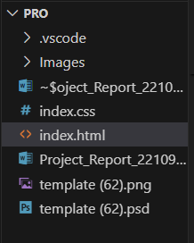

CODE RESULTS:

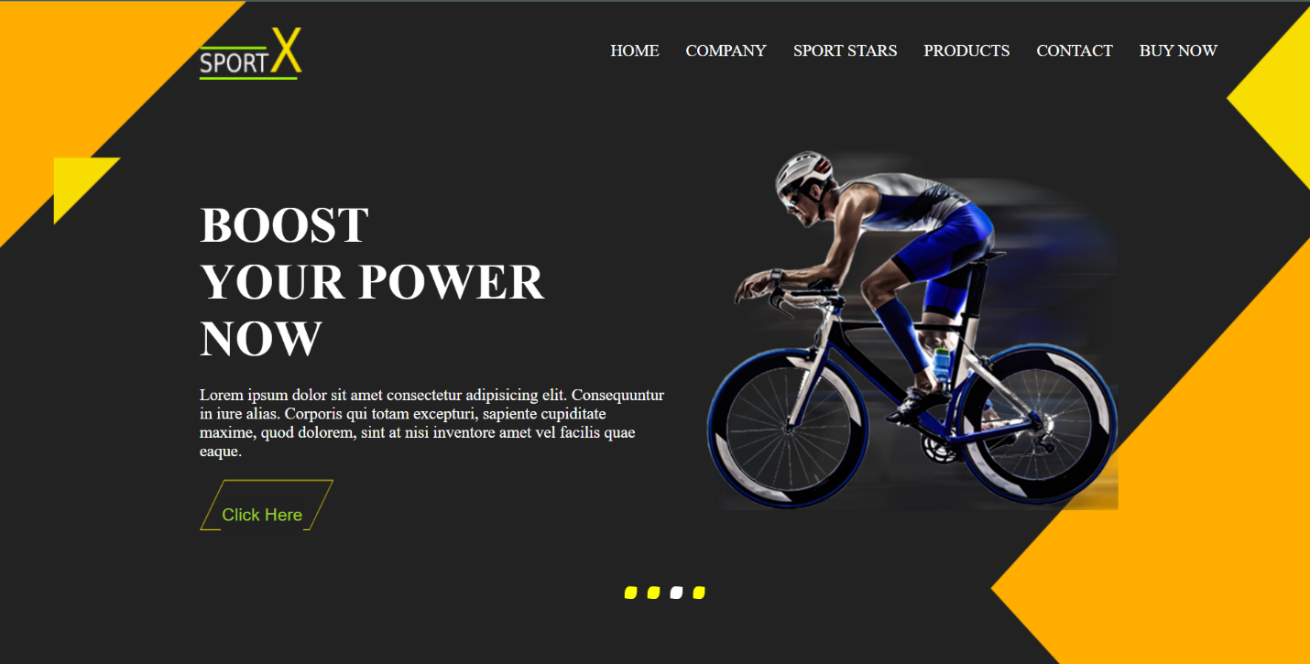

Figure 1

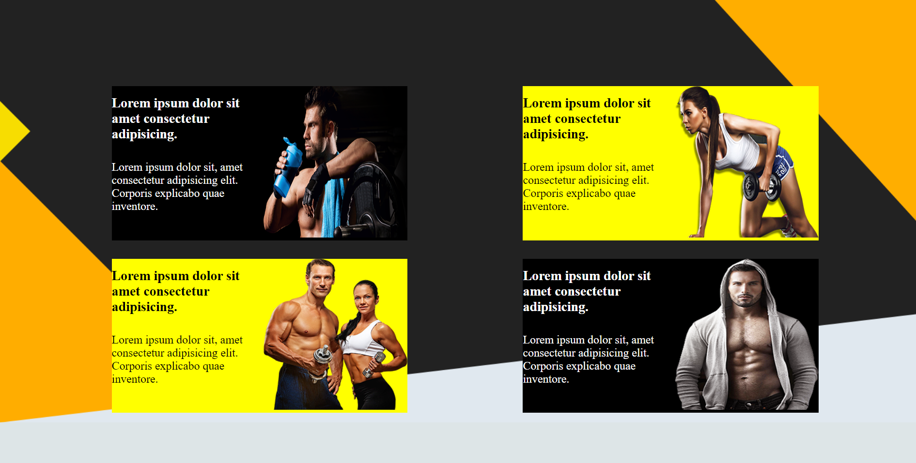

Figure 2

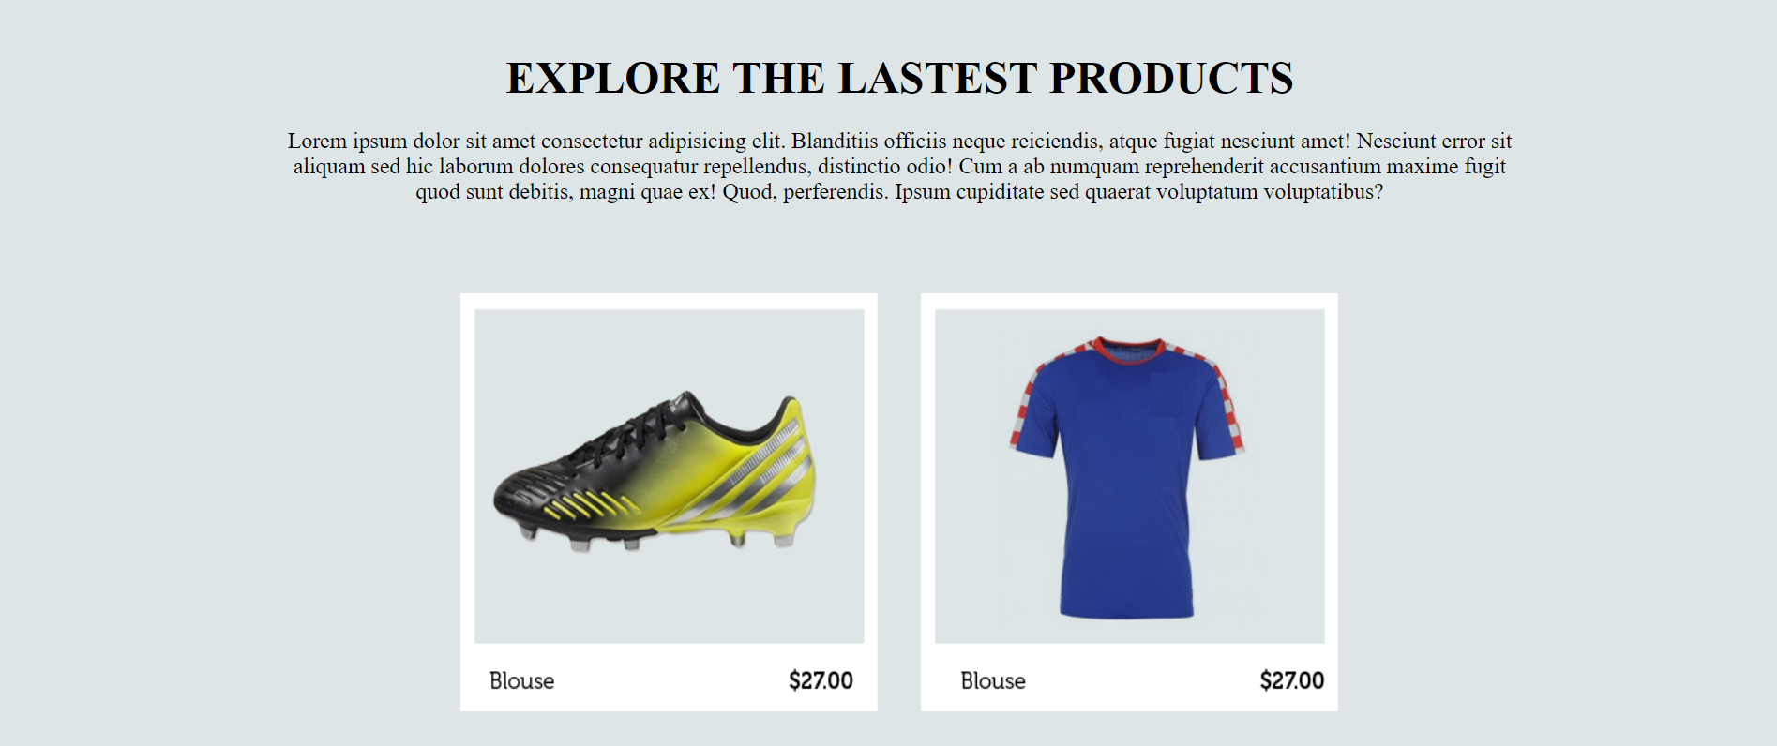

Figure 3

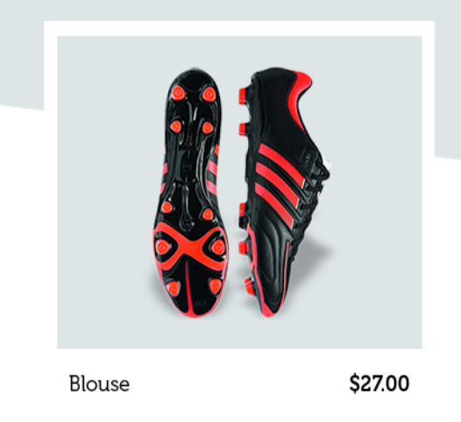

Figure 4

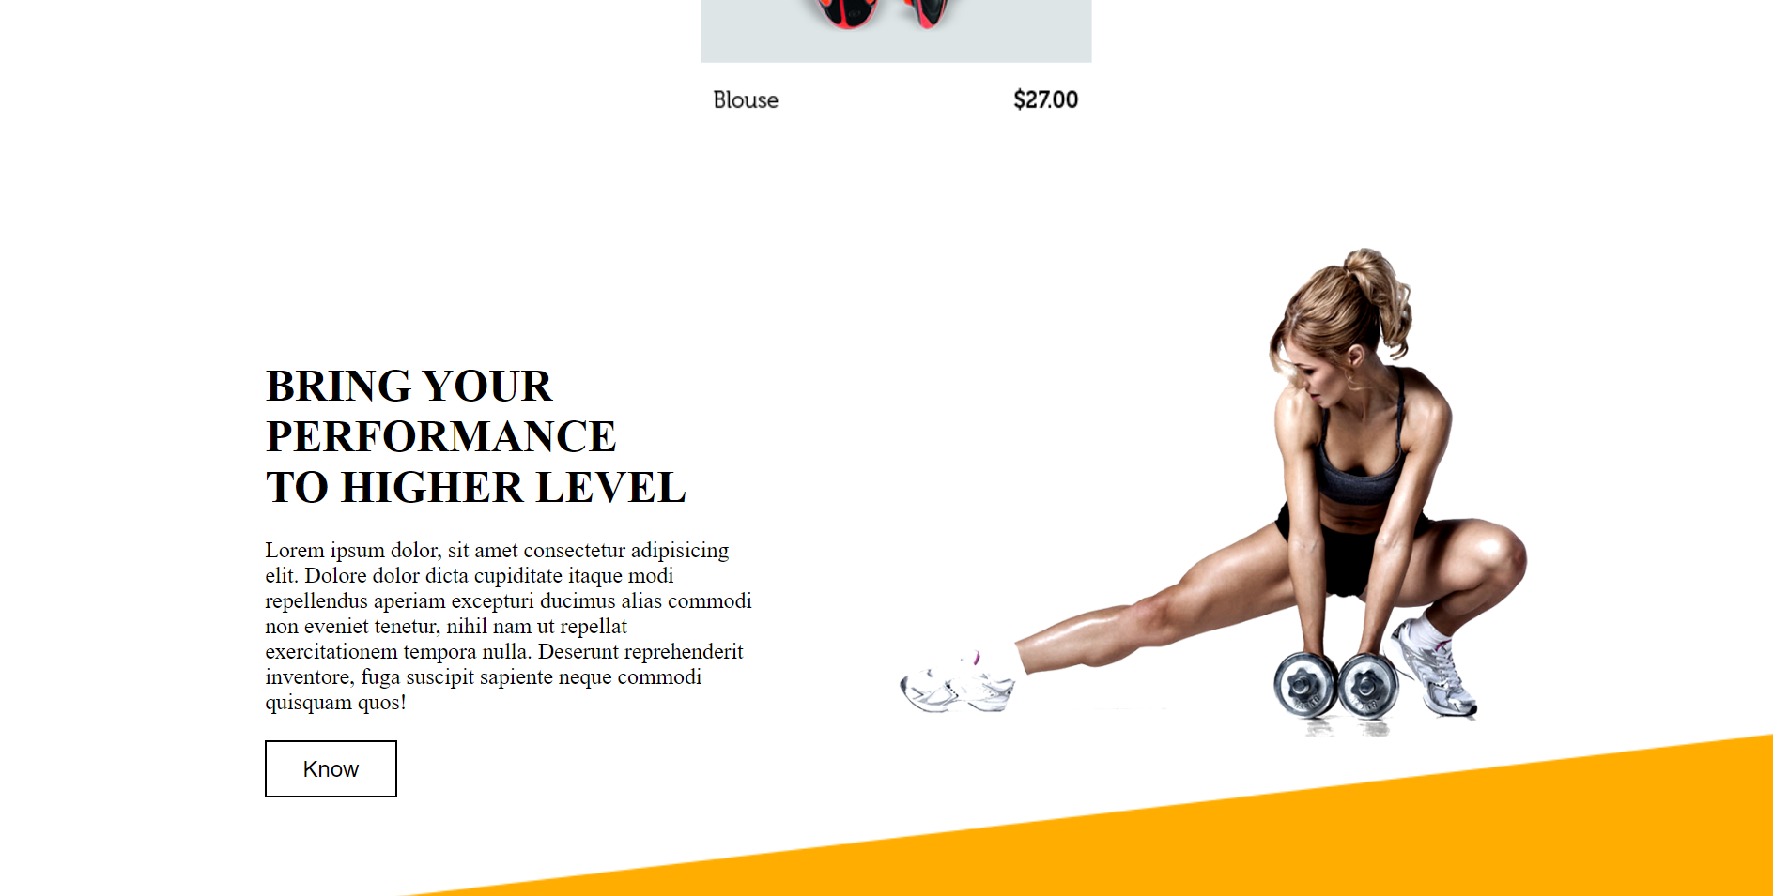

Figure 5

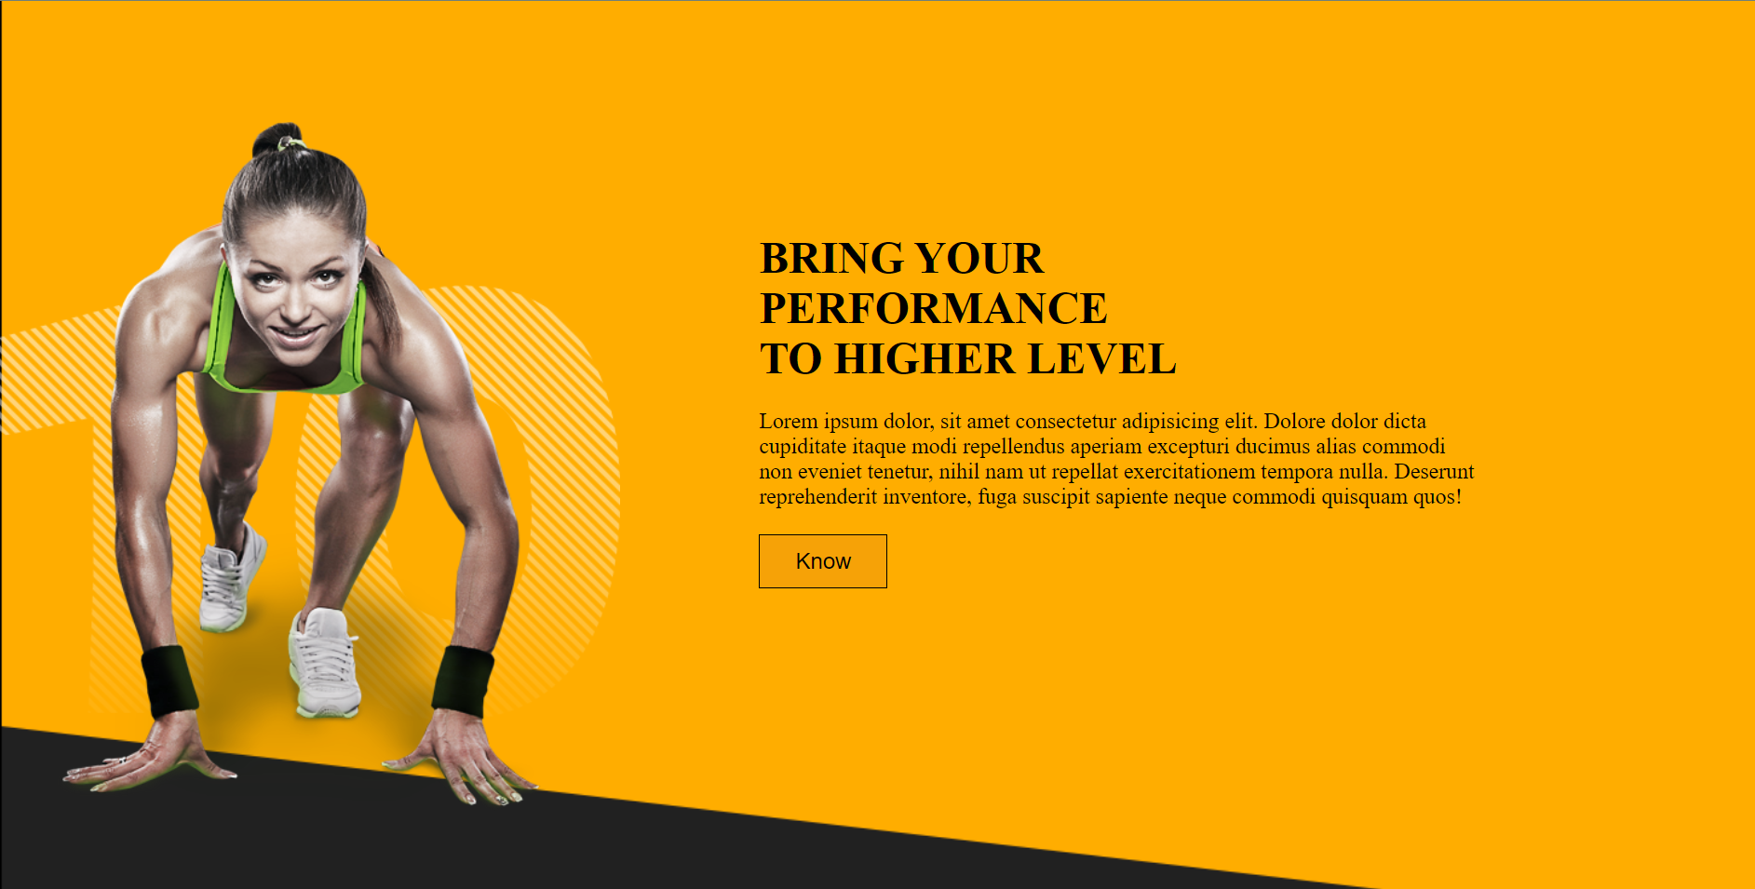

Figure 6



Figure 7

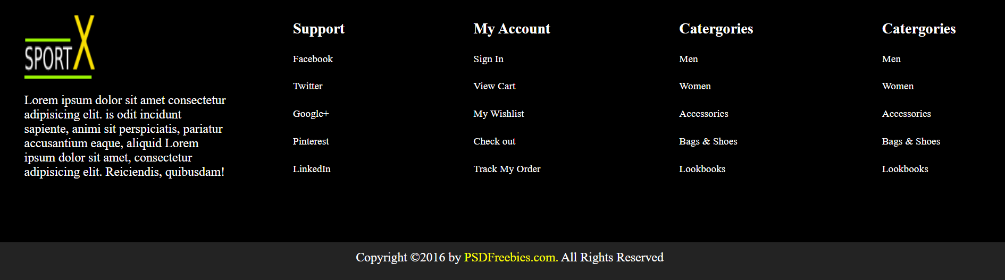

Figure 8

MOBILE VIEW:

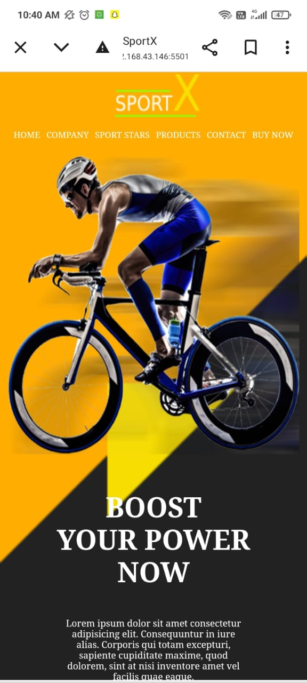

FIGURE 1

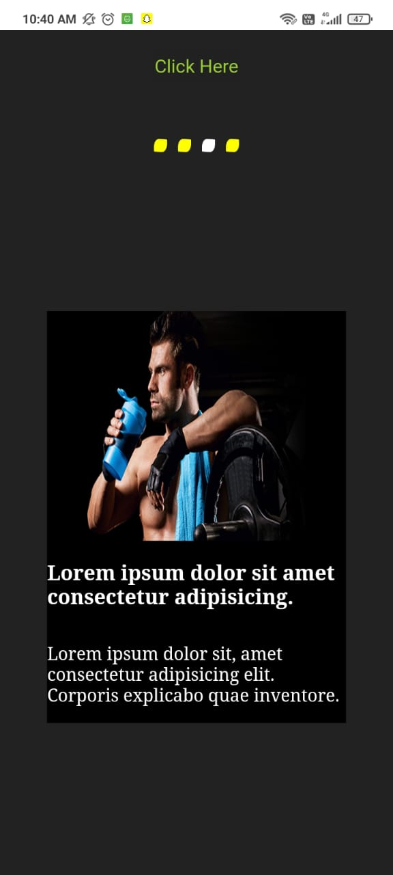

FIGURE 2

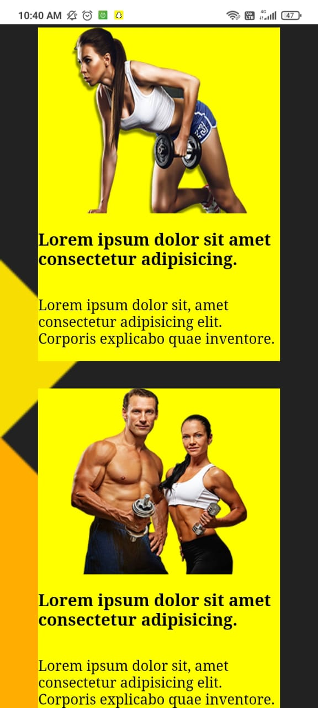

FIGURE 3

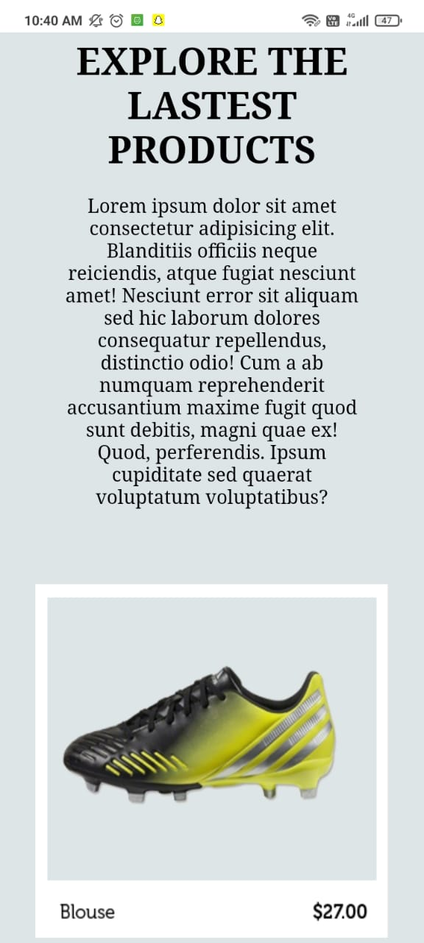

FIGURE 4

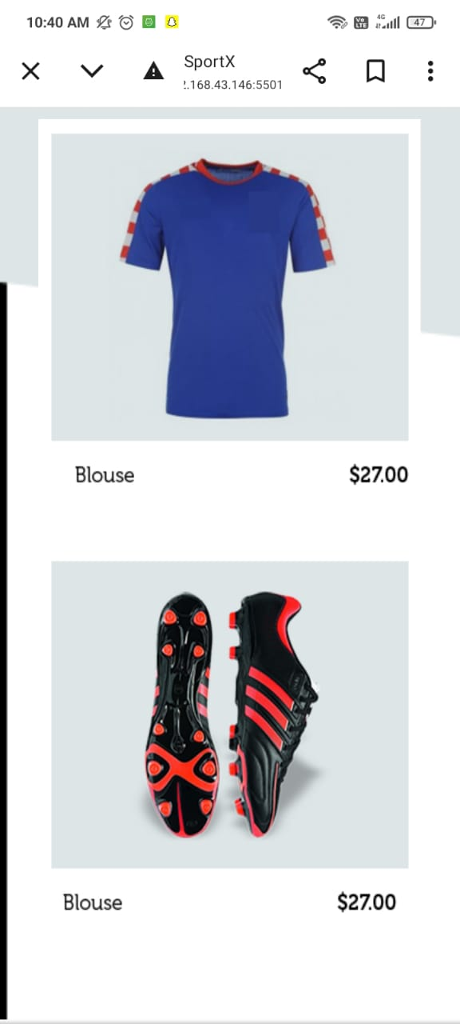

FIGURE 5



FIGURE 6

CODE Snapshots:-

HTML CODE

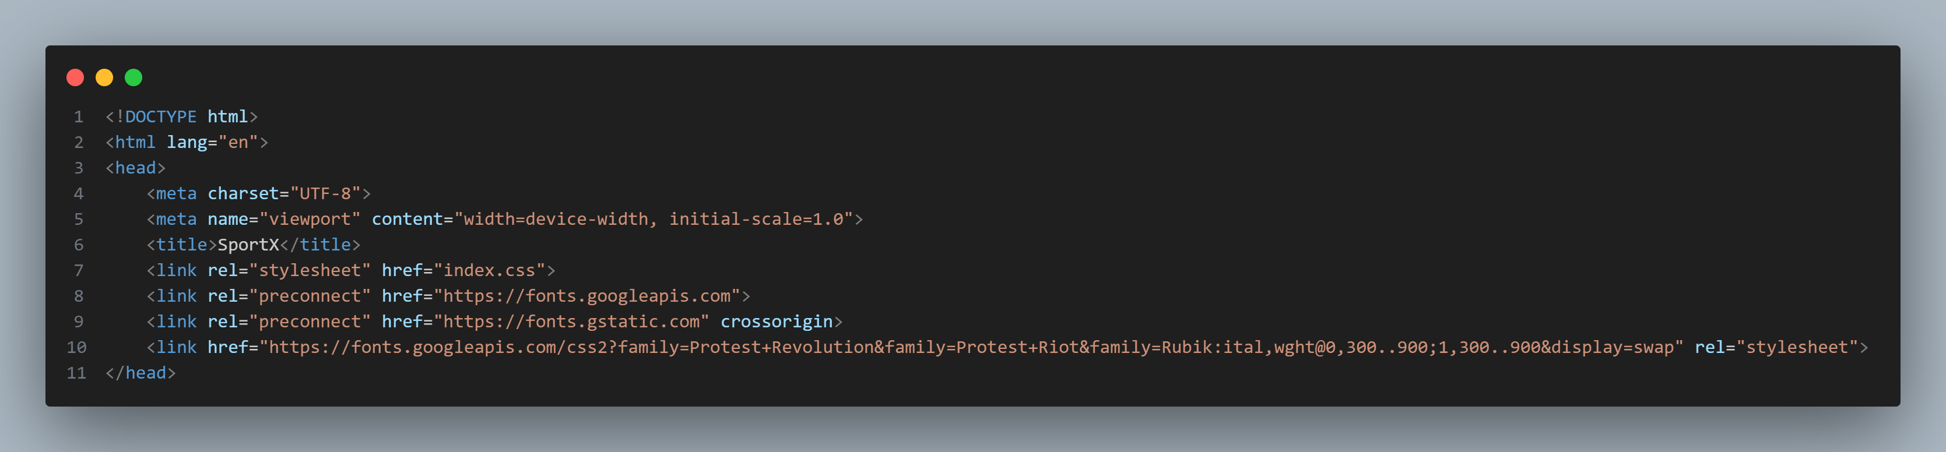

Figure 1[Head Tag]

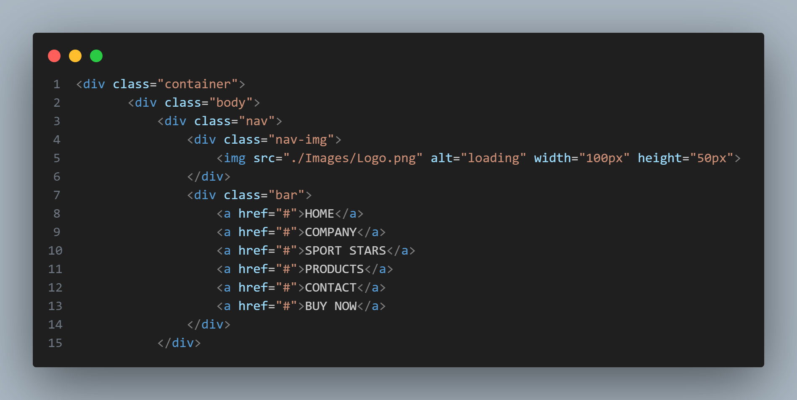Figure 2[navbar]

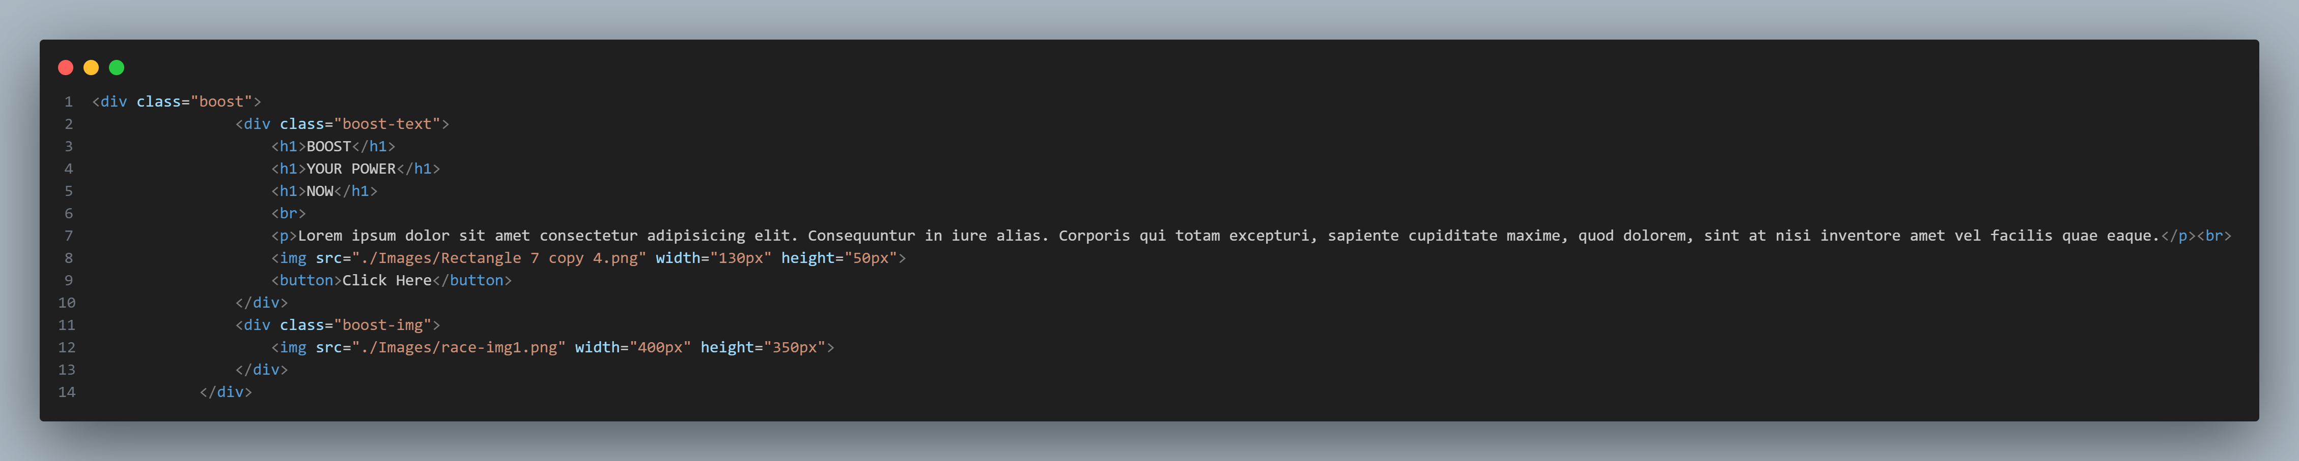

Figure 3[Boost Section]

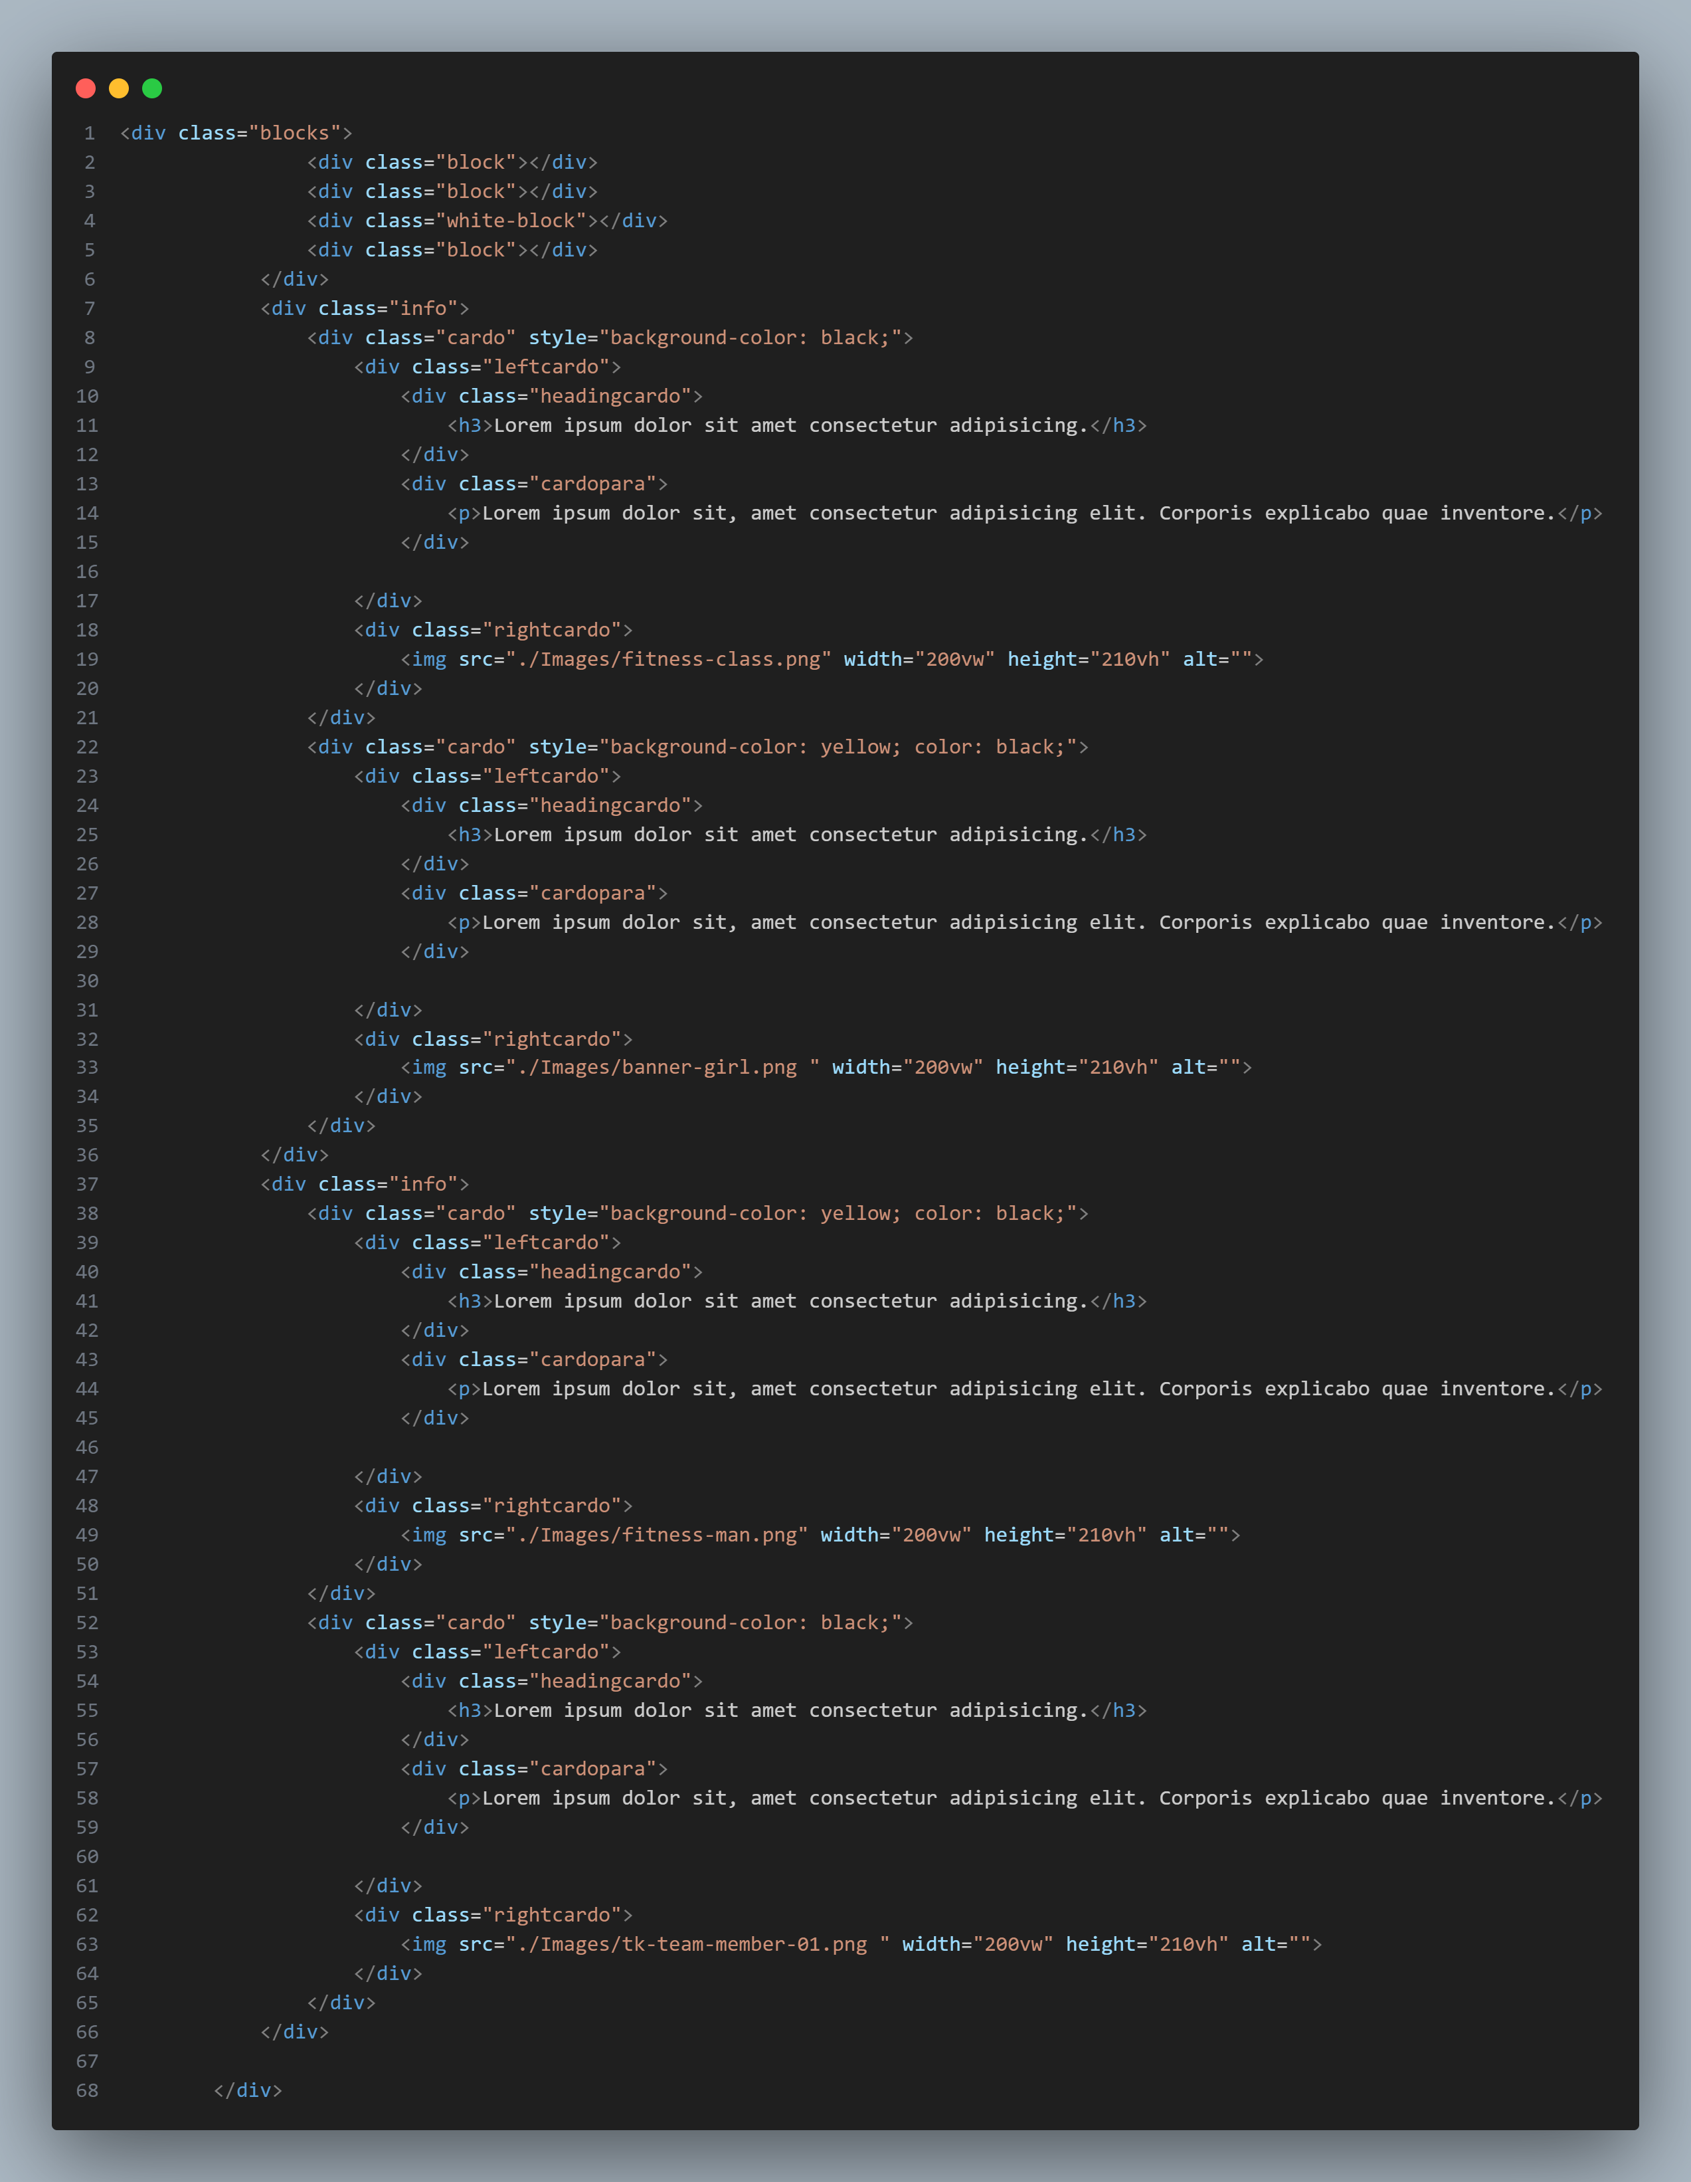

Figure 4[information section]

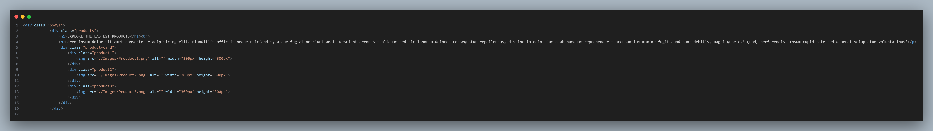

Figure 5 [Content section]

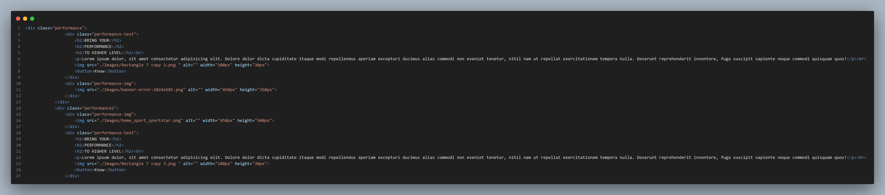

Figure 6[Performance Section]

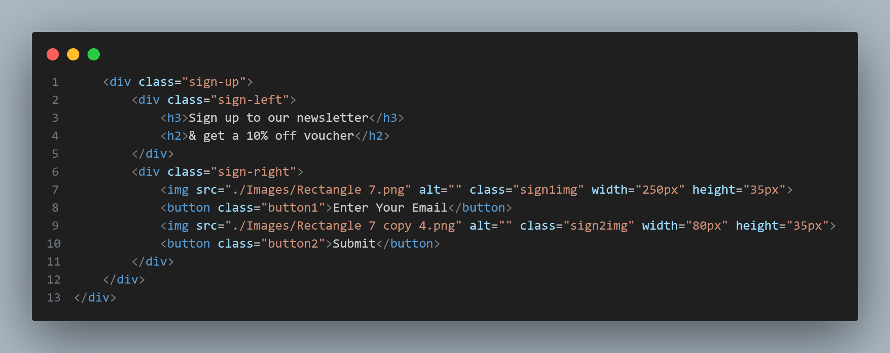

Figure 7[Sign-Up Section]

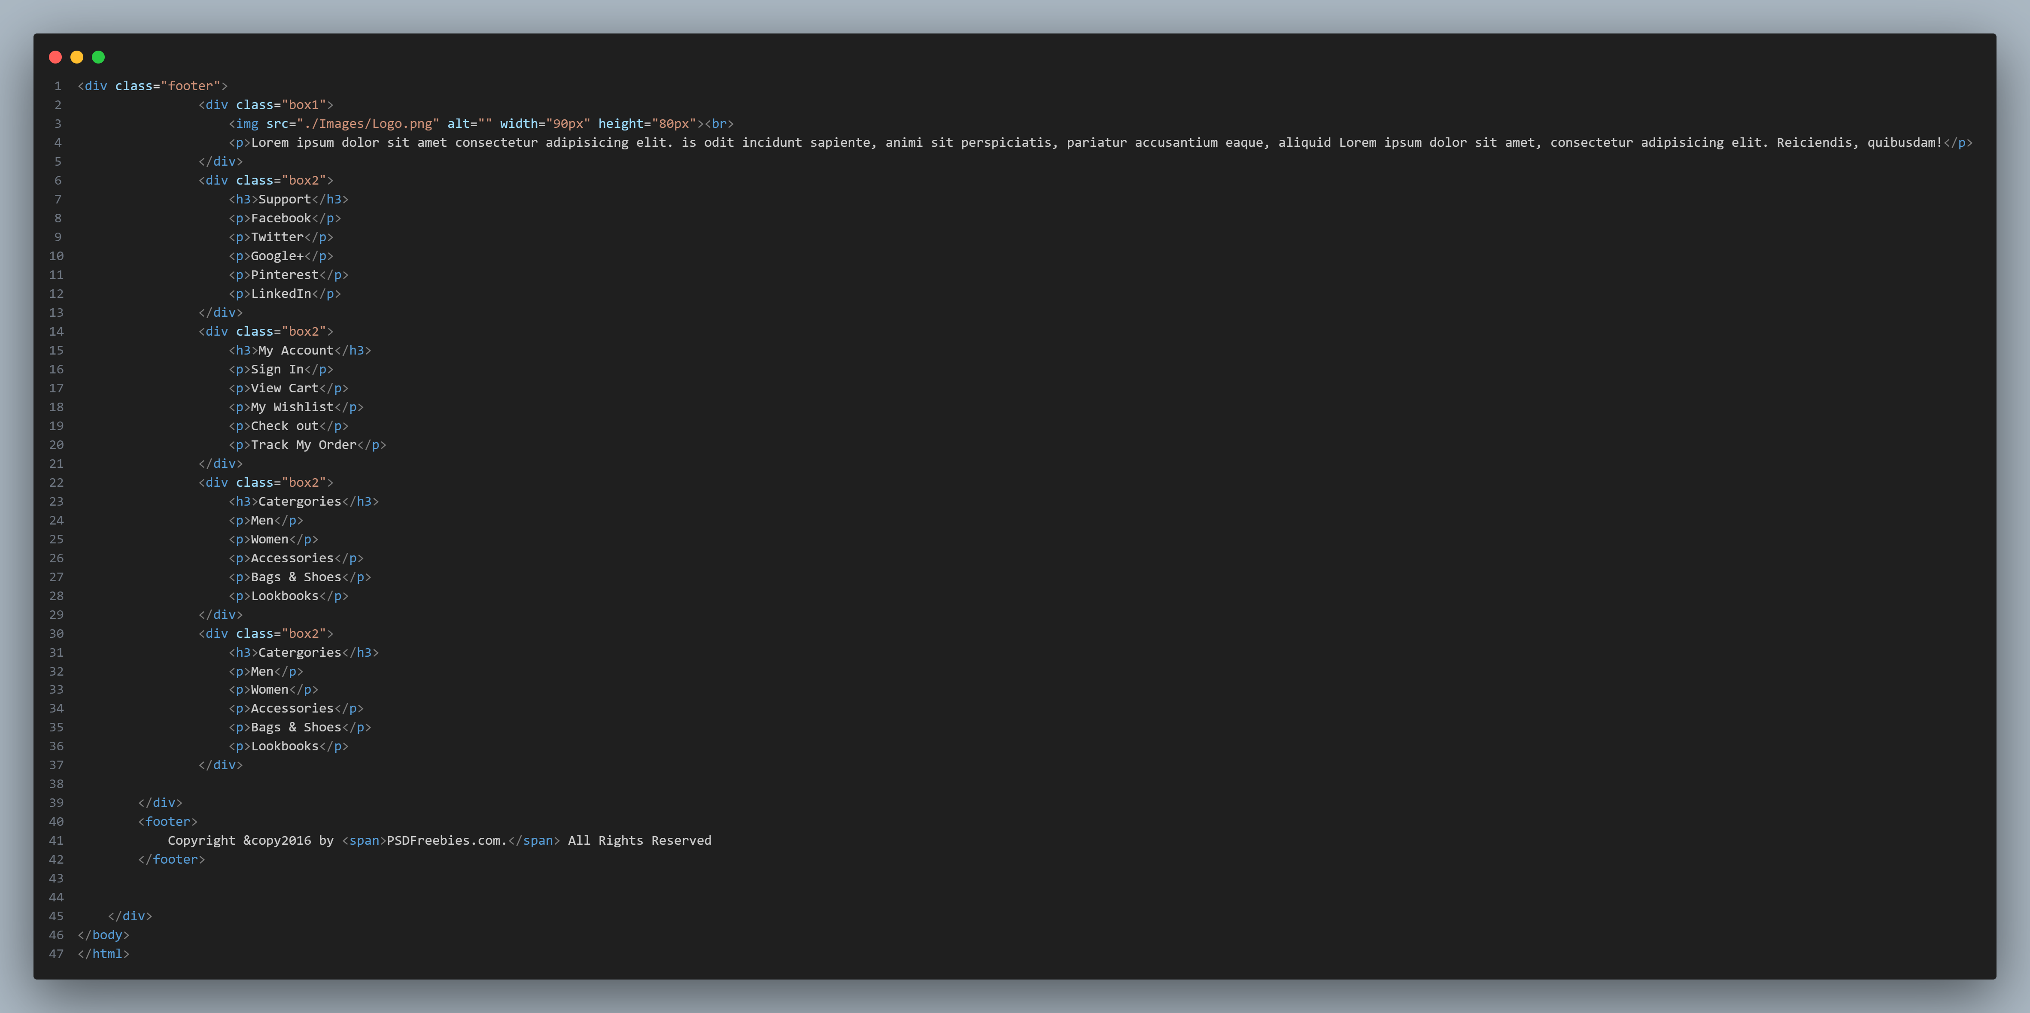

Figure 8[Footer&Copyright]

CSS CODE:-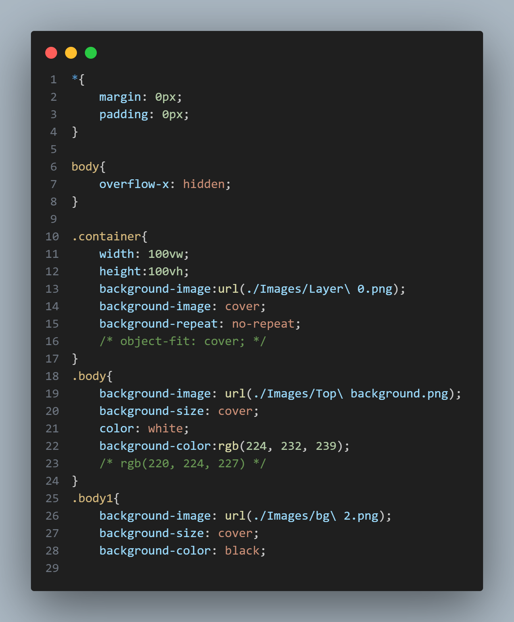

Figure 1

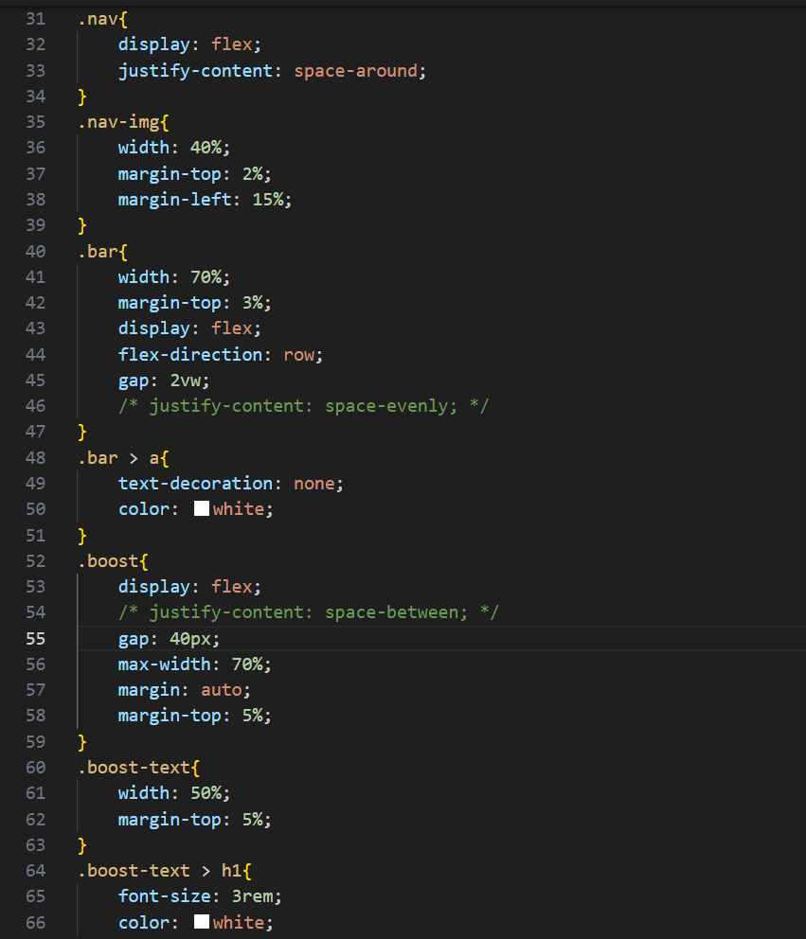

Figure 2

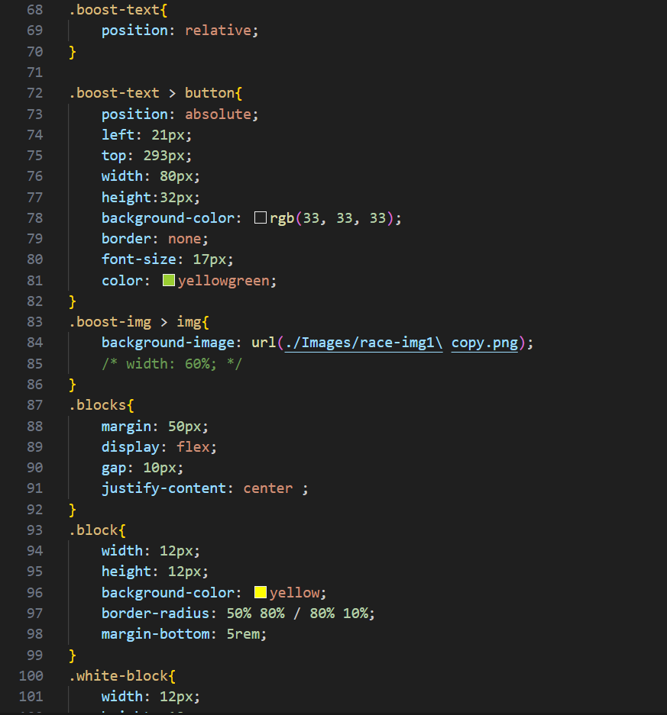

Figure 3

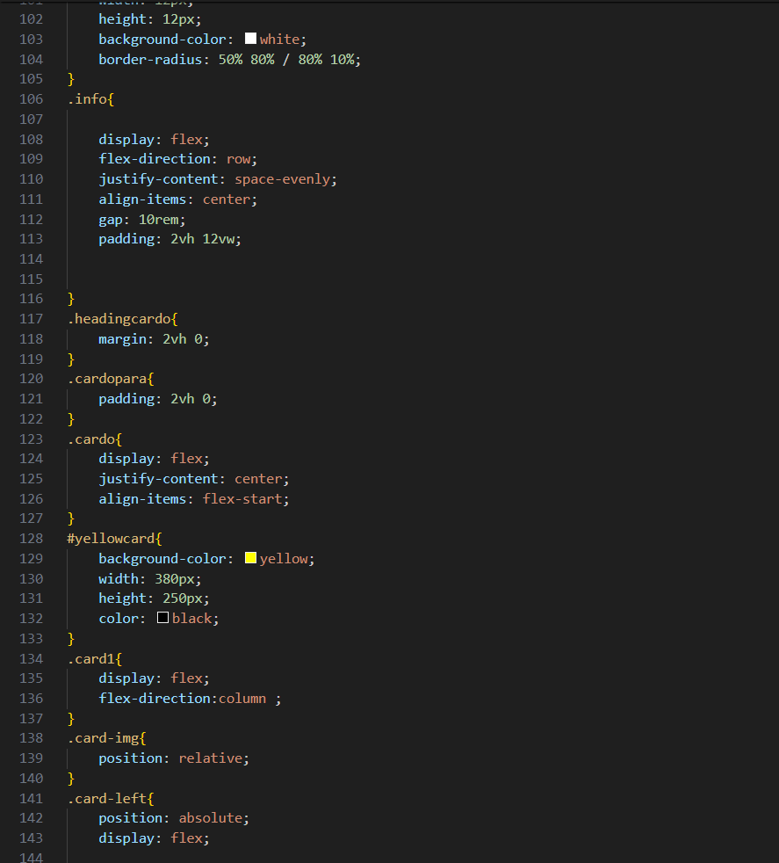

Figure 4

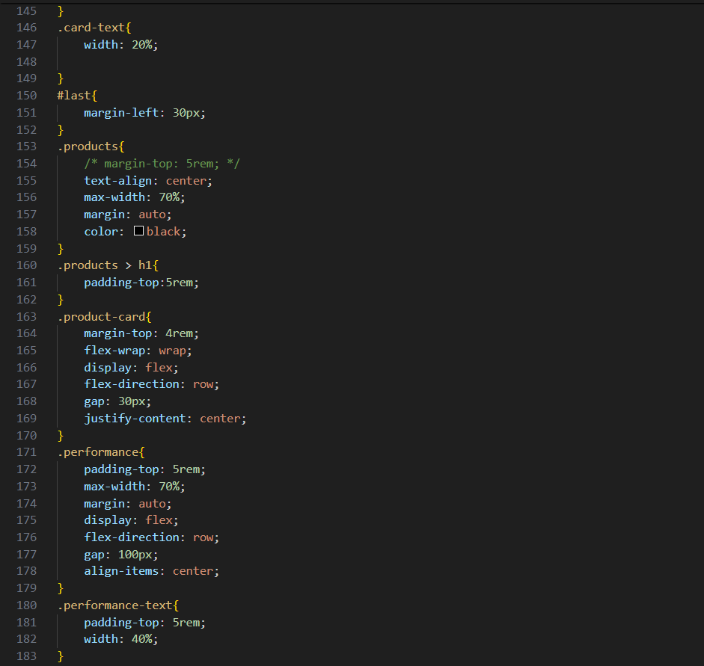

Figure 5

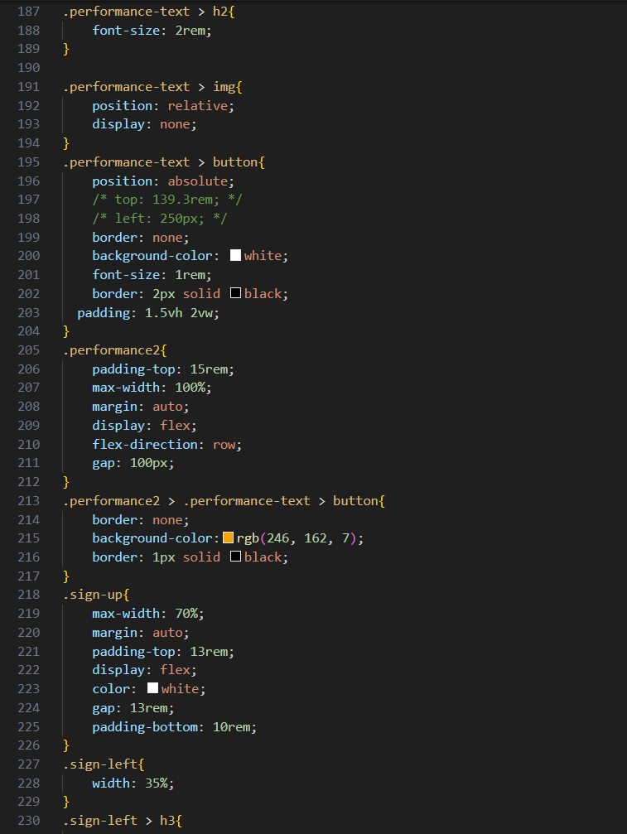

Figure 6

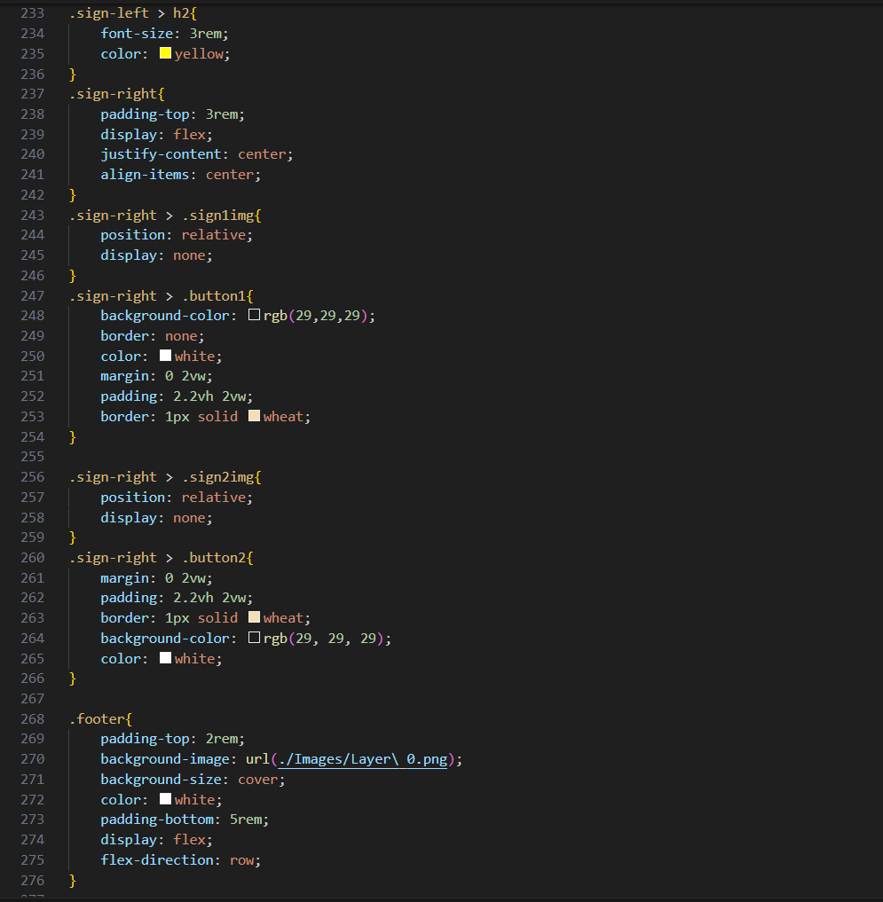

Figure 7

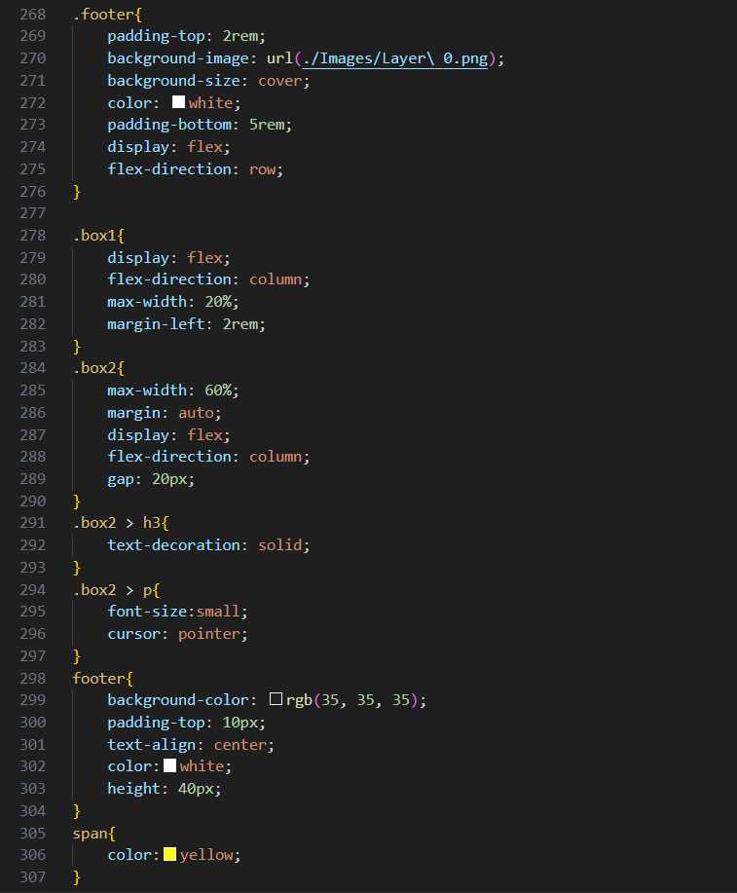

Figure 8

MEDIA QUERIES:-

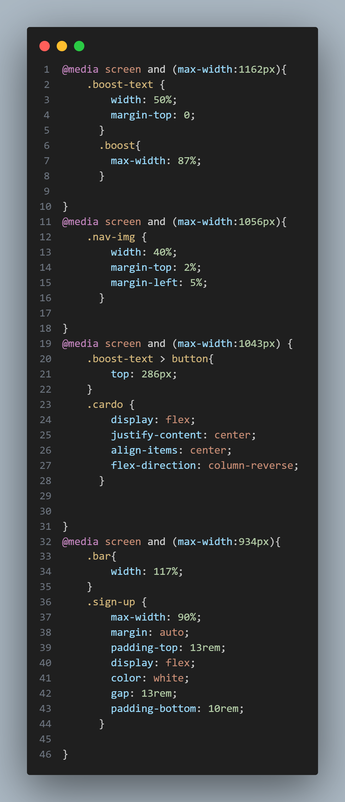

Figure 1

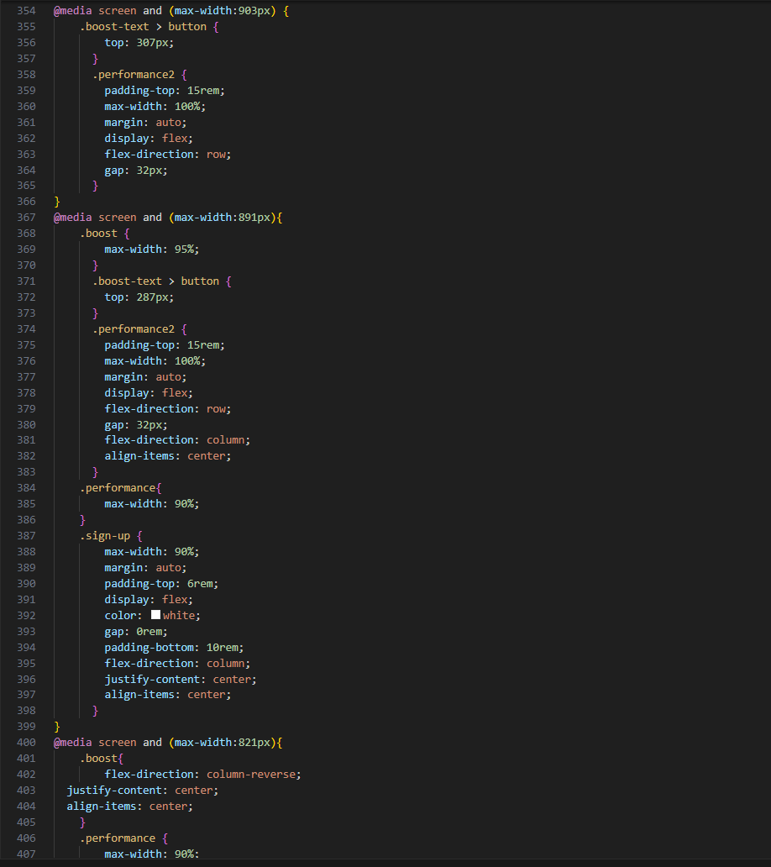

Figure 2

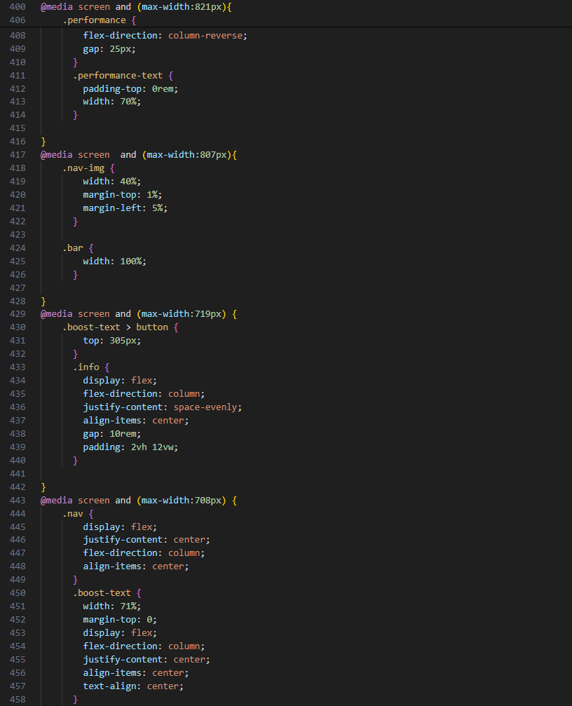

Figure 3

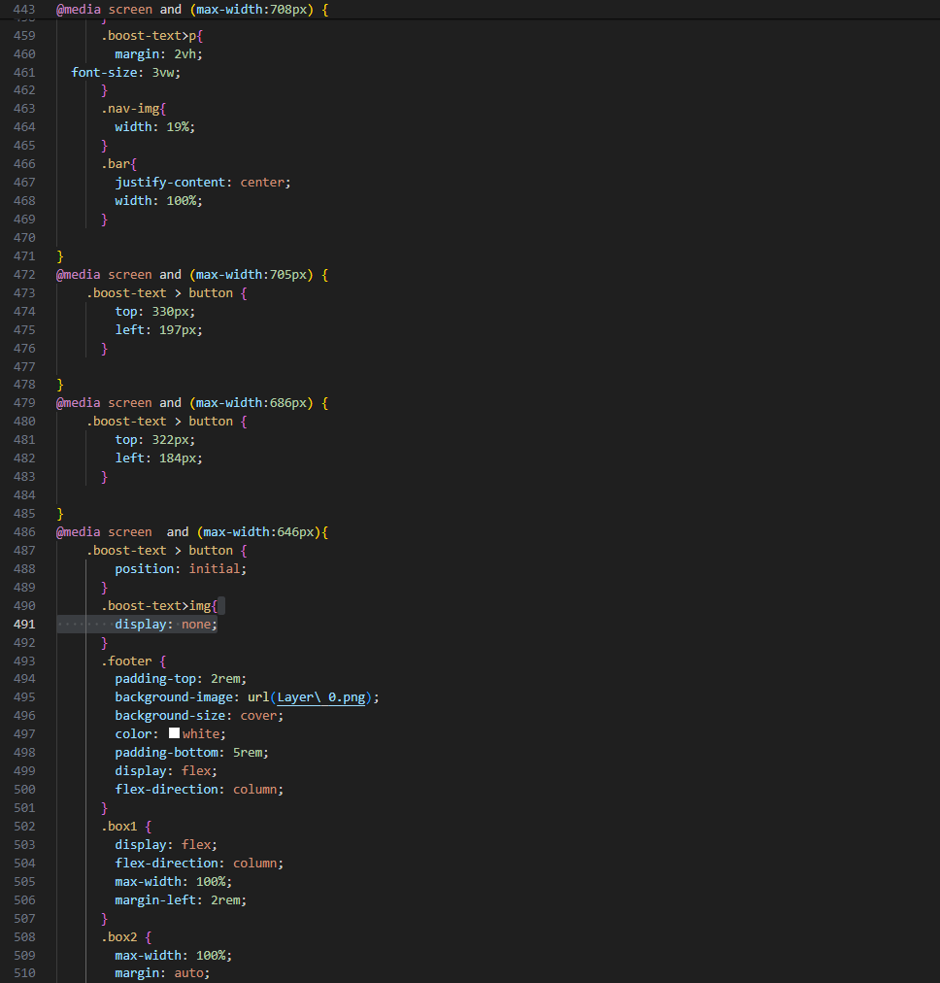

Figure 4

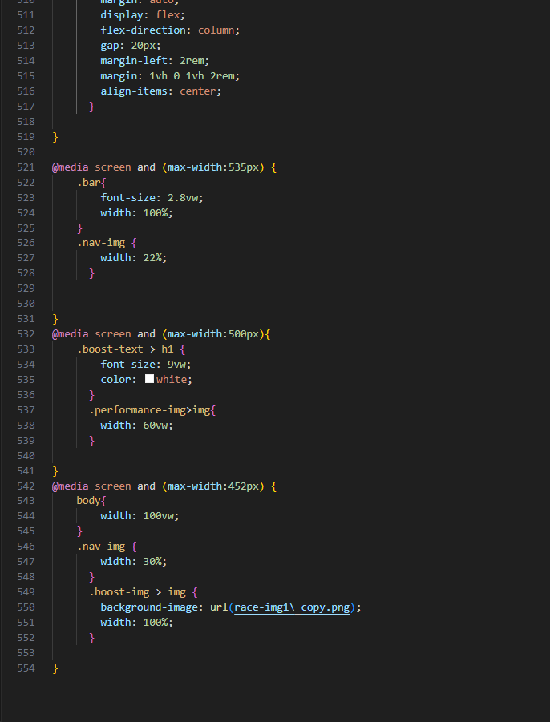

Figure 5

**References**

1. [www.photopea.com](http://www.photopea.com)
2. [www.w3schools.com](http://www.w3schools.com)
3. [www.psdFreebies.com](http://www.psdFreebies.com)
4. <https://fonts.google.com/>